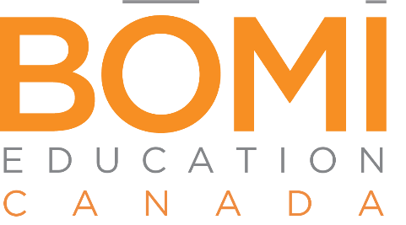

FOR IMMEDIATE RELEASE
Media Contact:
Cathy Calliotte
Director of Marketing
ccalliotte@bomi.org l 410-974-1410 x1257

BOMI Education Canada Announces Scholarship Winner
Paolo Cordovado Awarded Vyetta Sunderland Scholarship

Toronto, Ontario, October 3, 2022 – The Board of Directors of BOMI Education Canada is pleased to announce that this year’s annual Vyetta Sunderland Scholarship was awarded to Paolo Cordovado, Senior Building Operator, Avison Young.

BOMI Education Canada, in partnership with BOMI International, established the Vyetta Sunderland Scholarship in recognition of Sunderland’s focus on excellence and her lifelong commitment to education. The annual scholarship is awarded to a Canadian student who is in pursuit of advancing their property or facilities management career.

Cordovado began his career as a mobile building operator with Avison Young in 2010. He transitioned to a building operator and project manager at different firms, returning to Avison Young in 2019. Cordovado earned his Systems Maintenance Technician designation from BOMI Education Canada in 2018.

“Paolo’s commitment to enhancing his learning makes him the ideal recipient of the Vyetta Sunderland Scholarship,” said Laurie Ell, Chair of BOMI Education Canada and General Manager, REMS of Colliers. “Working with Vyetta Sunderland on various BOMI Boards and committees, I know she would agree that Paolo embodies the characteristics the committee seeks for the scholarship recipient.”

“I started my career in Property Management in 2010 and joined the Avison Young team in 2019 as a Building Operator. I always aim to achieve the highest satisfaction with my tenants, clients, and co-workers. As part of my employee engagement and dedication to my company, I have become a part of different internal groups, such as the Avison Young Global Engineering Taskforce, the Employee Resource Group for Emerging Leaders, and the AY Social Committee. I have completed my Building Environmental Systems class I & II and my Systems Maintenance Technician designation with BOMI. I’m very excited to get started on my SMA designation thanks to BOMI Education Canada.”

Cordovado was awarded the scholarship on September 15 at BOMA Canada’s BOMEX conference last week, held in Charlottetown, PEI. His father, Roberto, also in commercial property management, was in attendance as he accepted his award.

-more-

About BOMI Education Canada
BOMI Education Canada was formed in late 2019 to serve the training and development needs of commercial property professionals in Canada. BOMI Education Canada is led by a Board of Directors and supported by its partner, BOMI International. To learn more, please visit www.bomicanada.ca, call 647-256-1438 or 800-867-6049, or email service@bomicanada.ca.

# # #

